**User Journey of Insurance Policy Comparison Feature**



1. **URS (of your user journey)**

**Insurance Policy Comparison Feature**  
 The "Insurance Policy Comparison" feature is a central component of our Insurance Comparison and Management Mobile App, designed to empower users to make well-informed insurance decisions. This feature streamlines the process of comparing various insurance policies, including health, auto, and home insurance, by providing clear and comprehensive insights into policy details and costs.  


URS-001: Users select a type of insurance they want to compare.

URS-002: Users select how many insurance they want to compare.  
 URS-003: Users fill in the insurance details (health,auto,home, etc.).

URS-004: Users select the insurance to be compared.

URS-005: Users receive comparison results.

URS-006: Users see the recommended insurance that suits them.

1. **SRS (of your user journey)**



SRS-001: System shows a list of insurance types.

SRS-002: System asks the user how many comparisons they want to make.  
 SRS-003: System receives data entered by the user and searches in the database.

SRS-004: System displays a list of insurances related to that type.

SRS-005: System shows the results of the comparison for each insurance.

SRS-006: System generates the recommended insurance that is suitable for users.

1. **Use Case Diagram (All features)**

**Feature1:** Insurance Policy Comparison

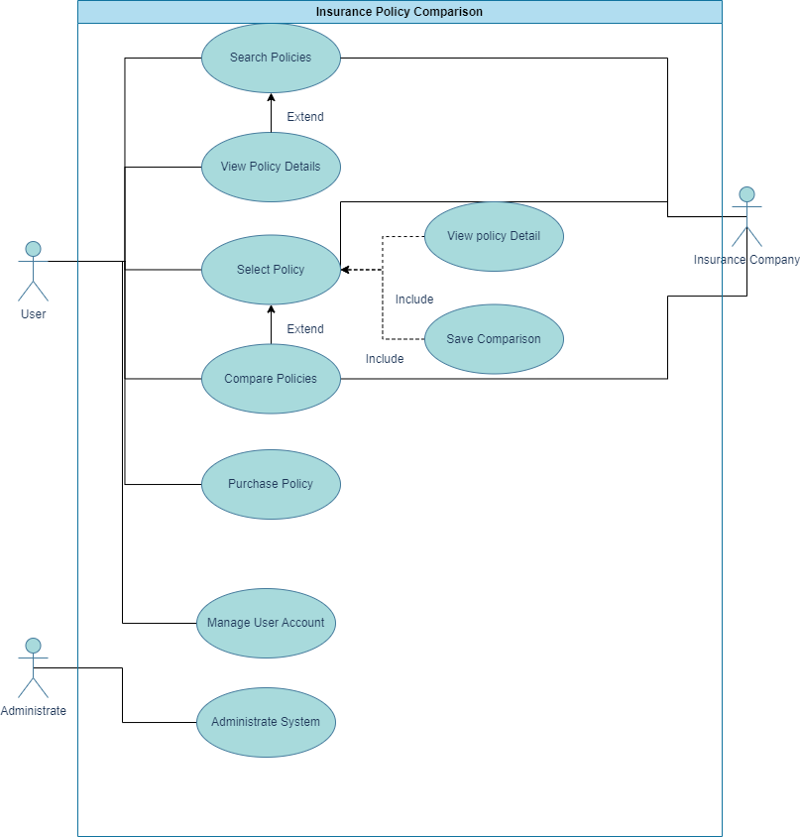

**Feature2:** Claims Submission/Management

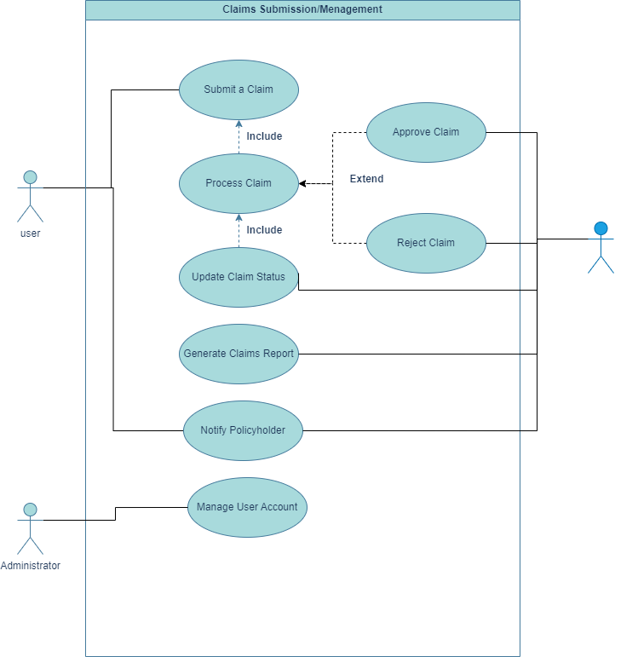

**Feature3:** Claims Tracking

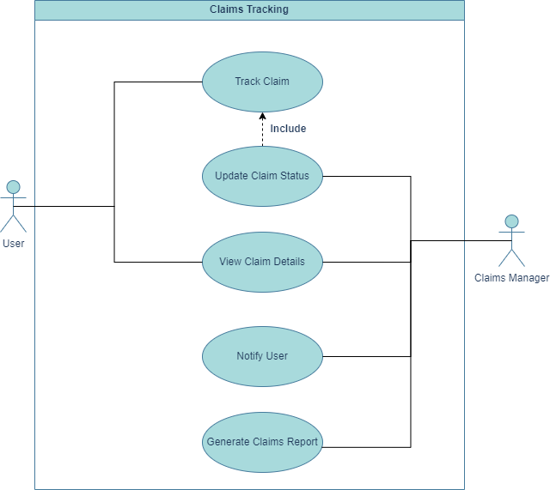

**Feature4:** Personalized Recommendations

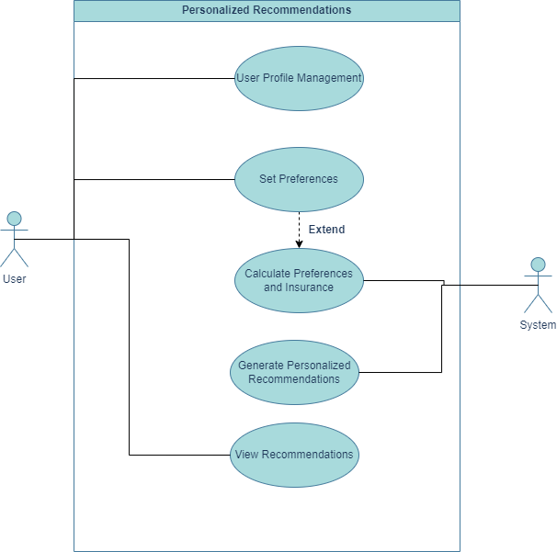

**Feature5:** Notification and Alerts

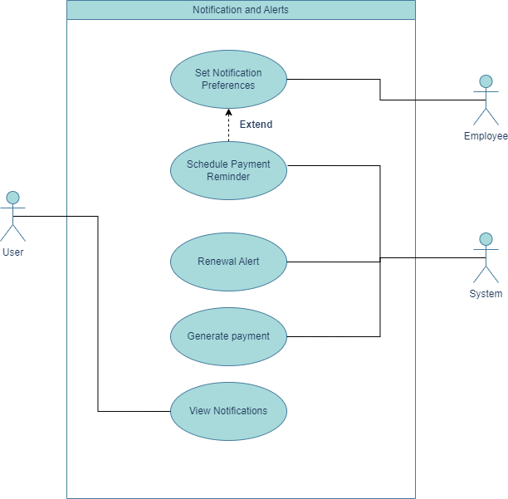

**Feature6:** Feedback

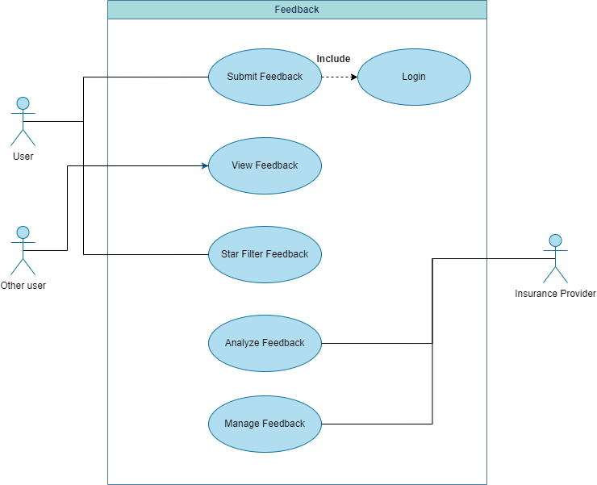

**Feature7:** Support Live Chat

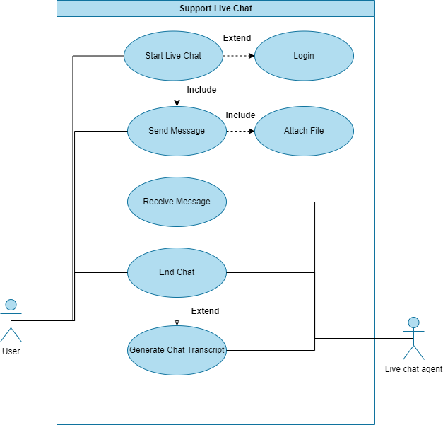

1. **Use Case Description (of your user journey)**

| Use Case ID | UC-001 | | | | |
| --- | --- | --- | --- | --- | --- |
| Use Case Name | Select a type of insurance | | | | |
| Created By | Group 4 - Yotsawat | | Last Update By | Group 4 - Yotsawat | |
| Date Created | 18/09/2023 | | Last Revision Date | 18/09/2023 | |
| Actors | Customer: The individual seeking to purchase or modify insurance coverage. | | | | |
| Description | This use case describes the process of a customer exploring and selecting a specific type of insurance coverage from the available options offered by the insurance provider, without requiring the customer to log in. | | | | |
| Trigger | When the customer decides to explore or select a specific type of insurance coverage. | | | | |
| Preconditions | None | | | | |
| Use Case Input Specification | | | | | |
| Input | type | Constraint | | | Example |
| Select the insurance | Life Insurance | The selected type must be one of the available insurance options provided by the insurance provider. | | | Customer selects "Life Insurance." |
| Post conditions | The selected type of insurance coverage is noted for reference. | | | | |
| Normal Flows | | | | | |
|  | | User | | System | |
|  | 1. Visits the insurance provider's website or application. 2. Navigates to the insurance selection or coverage exploration section. 3. Selects a type of insurance coverage. | | 1. Displays the insurance selection screen. 2. Lists available insurance types. 3. Records the customer's selection and retrieves associated details. | | |
| Alternative Flow | If the customer decides not to proceed with selecting an insurance type, they can explore other sections or exit the system. | | | | |
| Exception Flow | If there are technical issues or errors during the process, the system should display an error message and provide options for the customer to retry or contact customer support. | | | | |
| Assumption | * The customer does not need to log in for exploration or selection. * The insurance provider offers multiple types of insurance coverage. * The system is capable of presenting insurance options and retrieving details without requiring authentication. | | | | |

| Use Case ID | UC-002 | | | | |
| --- | --- | --- | --- | --- | --- |
| Use Case Name | Select how many insurance policies to be compare | | | | |
| Created By | Group 4 - Yotsawat | | Last Update By | Group 4 - Yotsawat | |
| Date Created | 18/09/2023 | | Last Revision Date | 18/09/2023 | |
| Actors | Customer: The individual interested in comparing insurance policies. | | | | |
| Description | This use case describes the process of a customer selecting how many insurance policies they want to compare from a list of available options. | | | | |
| Trigger | When the customer decides to compare multiple insurance policies. | | | | |
| Preconditions | 1. The customer is on the insurance comparison screen. 2. Insurance policies available for comparison are displayed. | | | | |
| Use Case Input Specification | | | | | |
| Input | type | Constraint | | | Example |
|  | Number | The selected number must be within the range of available policies for comparison. | | | Customer selects "3" policies to compare. |
| Post conditions | The customer has selected the number of policies they want to compare. | | | | |
| Normal Flows | | | | | |
|  | | User | | System | |
|  | 1. Navigates to the insurance comparison section. 2. Selects the number of policies to compare. | | 1. Displays the available insurance policies for comparison. 2. Records the customer's selection. | | |
| Alternative Flow | If the customer decides not to proceed with comparing policies, they can exit the comparison section. | | | | |
| Exception Flow | If there are technical issues or errors during the process, the system should display an error message and provide options for the customer to retry or contact customer support. | | | | |
| Assumption | * The customer is presented with a range of available insurance policies for comparison. * The system can handle the selection of the number of policies for comparison. * The system provides accurate and up-to-date information about the available policies. | | | | |

| Use Case ID | UC-003 | | | | |
| --- | --- | --- | --- | --- | --- |
| Use Case Name | Fill in the insurance details | | | | |
| Created By | Group 4 - Yotsawat | | Last Update By | Group 4 - Yotsawat | |
| Date Created | 18/09/2023 | | Last Revision Date | 18/09/2023 | |
| Actors | Customer: The individual seeking to purchase an insurance policy and provide necessary details. | | | | |
| Description | This use case describes the process of a customer filling in the required details to purchase an insurance policy. | | | | |
| Trigger | When the customer decides to purchase an insurance policy after selecting the policy to buy. | | | | |
| Preconditions | 1. The customer has selected an insurance policy to purchase. 2. The customer is on the insurance policy details and purchase screen. | | | | |
| Use Case Input Specification | | | | | |
| Input | type | Constraint | | | Example |
|  |  | The customer must provide accurate and complete information as required for the selected insurance policy. | | | Customer provides personal information, coverage preferences, and payment details. |
| Post conditions | The customer has filled in all the required insurance details for the selected policy. | | | | |
| Normal Flows | | | | | |
|  | | User | | System | |
|  | 1. Selects an insurance policy to purchase. 2. Fills in the required policy details. 3. Confirms the purchase. | | 1. Displays policy details and requirements. 2. Validates and records the provided information. 3. Processes the purchase transaction. | | |
| Alternative Flow | If the customer decides not to proceed with the purchase or leaves the page without completing the details, they can exit the process. | | | | |
| Exception Flow | If the customer provides incomplete or incorrect information, the system should display error messages and prompt for corrections.  If there are technical issues or errors during the process, the system should display an error message and provide options for the customer to retry or contact customer support. | | | | |
| Assumption | * The customer has selected a specific insurance policy. * The system can handle various types of insurance policies with different data requirements. * The system securely processes payment information if required for the purchase. * The customer is provided with clear guidance on what information is required to complete the purchase. | | | | |

| Use Case ID | UC-004 | | | | |
| --- | --- | --- | --- | --- | --- |
| Use Case Name | Select the insurance to be compared | | | | |
| Created By | Group 4 - Yotsawat | | Last Update By | Group 4 - Yotsawat | |
| Date Created | 18/09/2023 | | Last Revision Date | 18/09/2023 | |
| Actors | Customer: The individual interested in comparing multiple insurance policies. | | | | |
| Description | This use case describes the process of a customer selecting the specific insurance policies they want to compare from a list of available options.. | | | | |
| Trigger | The trigger for this use case is when the customer decides to compare multiple insurance policies. | | | | |
| Preconditions | 1. The customer is on the insurance comparison screen. 2. Multiple insurance policies are available for comparison. | | | | |
| Use Case Input Specification | | | | | |
| Input | type | Constraint | | | Example |
|  |  | The customer can select one or more insurance policies to compare from the list of available options. | | | Customer selects "Auto Insurance" and "Home Insurance" for comparison. |
| Post conditions | The customer has selected the insurance policies they want to compare. | | | | |
| Normal Flows | | | | | |
|  | | User | | System | |
|  | 1. Navigates to the insurance comparison section. 2. Selects the insurance policies to be compared. | | 1. Displays the available insurance policies for comparison. 2. Records the customer's selections. | | |
| Alternative Flow | If the customer decides not to proceed with comparing policies, they can exit the comparison section. | | | | |
| Exception Flow | If there are technical issues or errors during the process, the system should display an error message and provide options for the customer to retry or contact customer support. | | | | |
| Assumption | * The customer is presented with a range of available insurance policies for comparison. * The system can handle the selection of one or more policies for comparison. * The system provides accurate and up-to-date information about the available policies. | | | | |

1. **Activity diagram (of your user journey)**

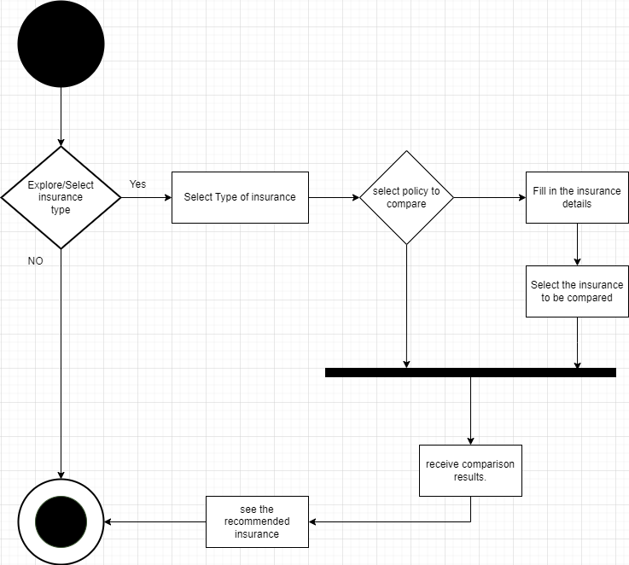

1. **Non-functional requirement with fit criteria**

**1. System Response Time**

**- Page Load Time  
Fit Criteria:** The average page load time for policy comparisons, claims submission, and other critical app functions should not exceed 3 seconds. **Measurement:** Page load times will be measured using performance monitoring tools and user testing.

**- API Response Time  
Fit Criteria:** API responses for retrieving policy details and processing claims should have a median response time of less than 1 second. **Measurement:** API response times will be monitored and recorded during load testing and real-world usage.

**- Transaction Processing Time  
Fit Criteria:** Completing a policy purchase transaction, from policy selection to payment confirmation, should take less than 5 minutes. **Measurement:** Transaction times will be measured during user testing and performance testing.

**- Concurrency Handling  
Fit Criteria:** The system should support concurrent user interactions without a significant increase in response time, even during peak usage. **Measurement:** Load testing will simulate concurrent user interactions and measure the impact on response times.

**- Error Handling Response Time  
Fit Criteria:** When an error occurs, such as a failed claim submission, the system should provide an error message within 2 seconds. **Measurement:** Error response times will be measured during testing scenarios where errors are intentionally triggered.

**- Mobile App Responsiveness  
Fit Criteria:** The mobile app should respond to user interactions (e.g., button clicks, menu selections) with no perceptible lag. **Measurement:** User testing and performance monitoring will assess app responsiveness.

**- Real-Time Updates  
Fit Criteria:** Real-time policy updates should be reflected to users within a maximum delay of 15 minutes from the time the update is available from the insurance provider.  
**Measurement:** Monitoring and tracking of policy update times from insurance providers.

**- User Feedback  
Fit Criteria:** User feedback related to system response time should indicate a high level of satisfaction, with at least 90% of users rating response times as "acceptable" or better in user surveys.  
**Measurement:** Periodic user surveys and feedback analysis.

**2. Real-Time Information**

**- Real-Time Policy Updates  
Fit Criteria:** Users should receive real-time policy updates within a maximum delay of 15 minutes from the time the update is available from the insurance provider. **Measurement:** Monitoring and tracking of policy update times from insurance providers.

**- Claims Tracking  
Fit Criteria:** Users should be able to track the status of their claims in real-time, with updates occurring within 30 minutes of any status change.  
**Measurement:** Claims tracking system logs and user feedback.

**3. Privacy**

**- Data Encryption  
Fit Criteria:** All sensitive user data, including personal information and financial details, must be encrypted using strong encryption algorithms (e.g., AES-256).  
**Measurement:** Regular security audits and vulnerability assessments to ensure encryption standards are met.

**- User Consent  
Fit Criteria:** Users must explicitly provide consent for data collection, processing, and sharing. The app should clearly communicate data usage policies, and users must have the option to opt out.  
**Measurement:** Tracking user consent settings and conducting user surveys to assess their understanding of data usage.

**4. Security**

**- Authentication and Authorization  
Fit Criteria:** Access to user accounts and sensitive functions (e.g., claims submission) should require strong authentication methods (e.g., multi-factor authentication). Unauthorized access attempts should trigger security alerts.  
**Measurement:** Monitoring of authentication logs and security alerts.

**- Penetration Testing  
Fit Criteria:** Regular penetration testing should be conducted to identify and address security vulnerabilities. The app should remain free of critical security issues. **Measurement:** Reports from penetration testing, security audits, and resolution of identified vulnerabilities.

**- Incident Response Time  
Fit Criteria:** In the event of a security incident, the app's security team should respond within 24 hours, investigate the incident, and take appropriate actions to mitigate any potential data breaches. **Measurement:** Records of incident reports, response times, and actions taken.

1. **UI (wireframe or prototype)**

**Insurance Policy Comparison**

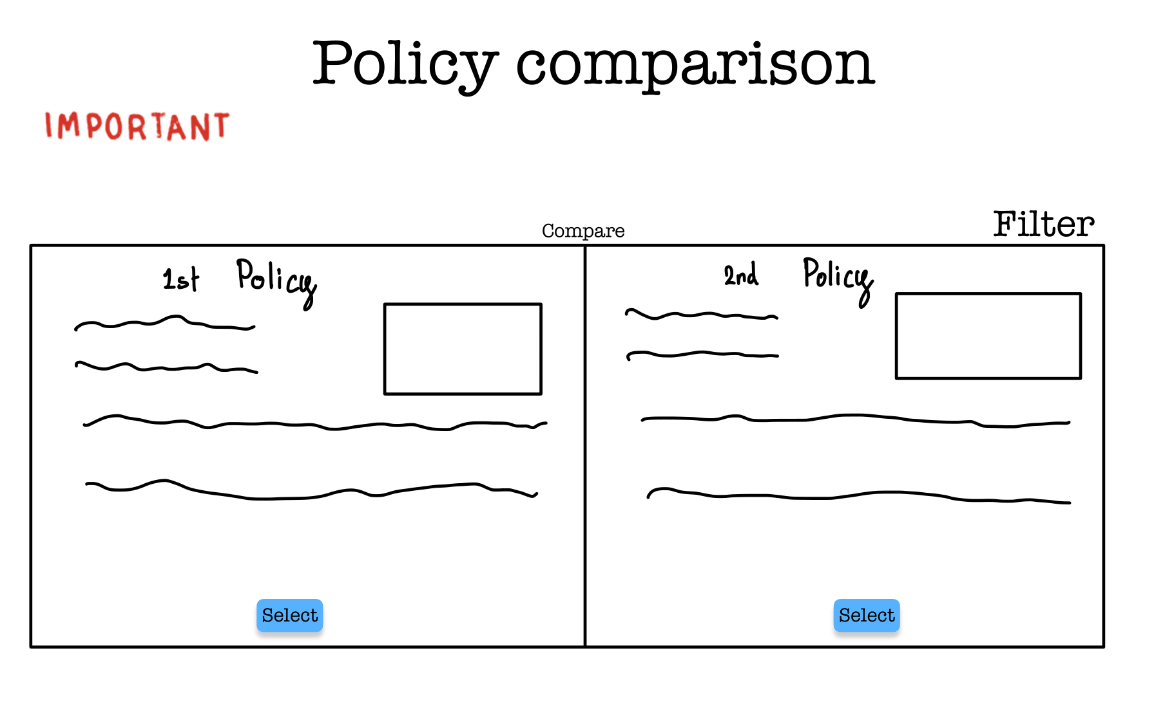

**Claims Submission/Management  
  
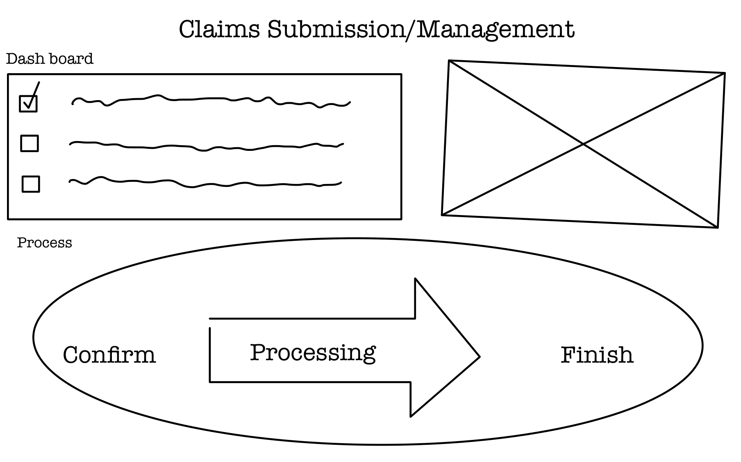**

**Claims Tracking  
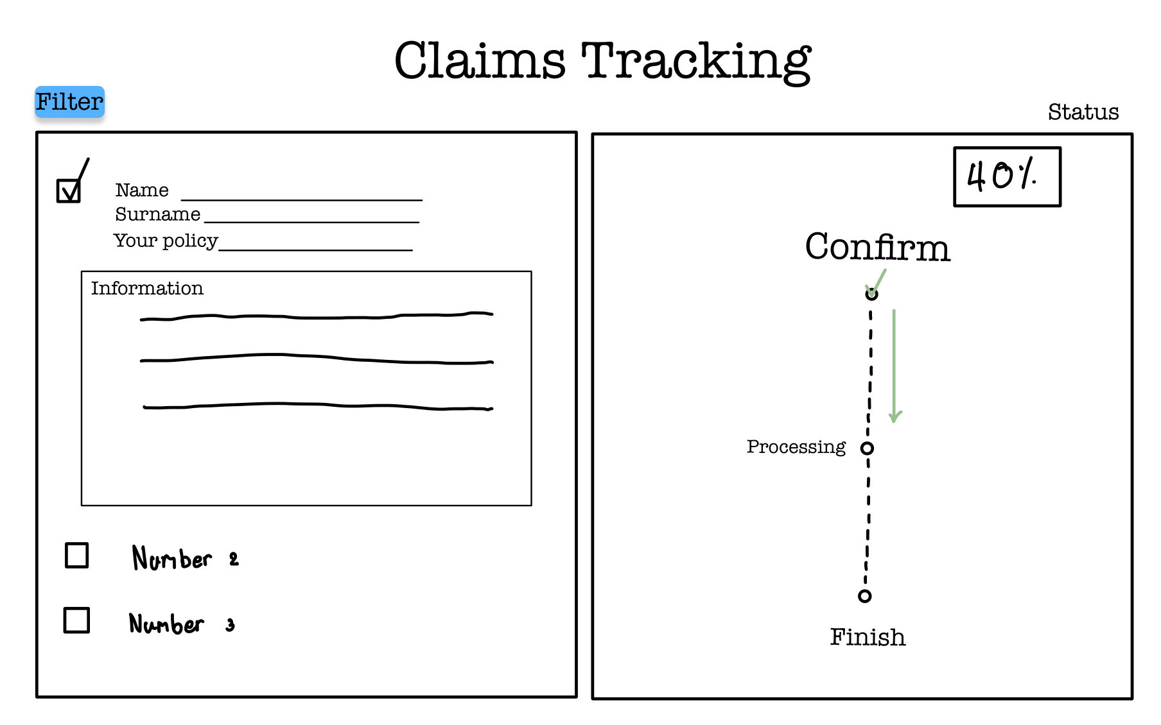  
  
Personalized Recommendations  
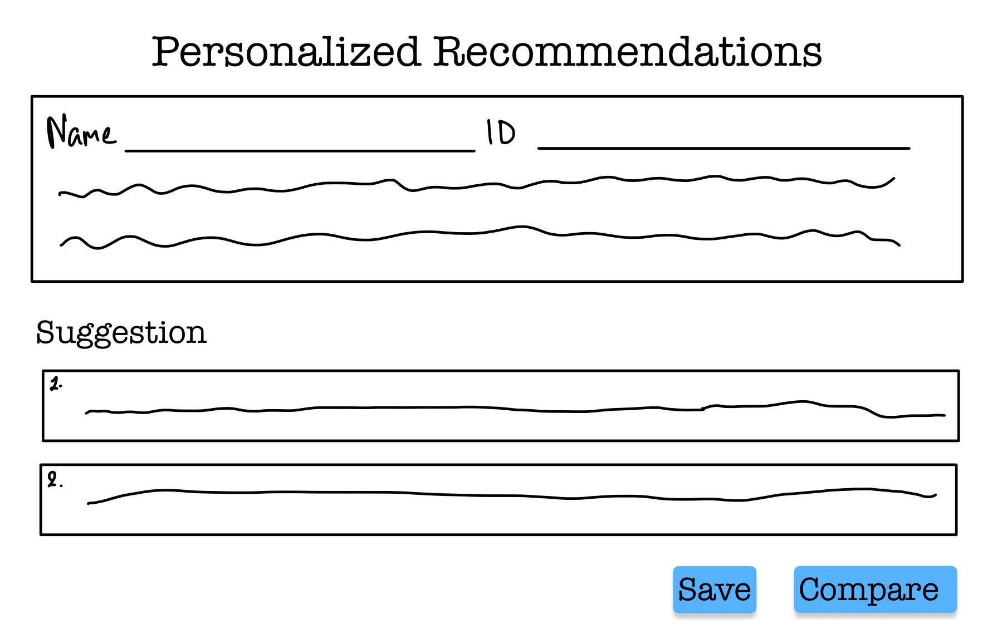**

**Notification and Alerts  
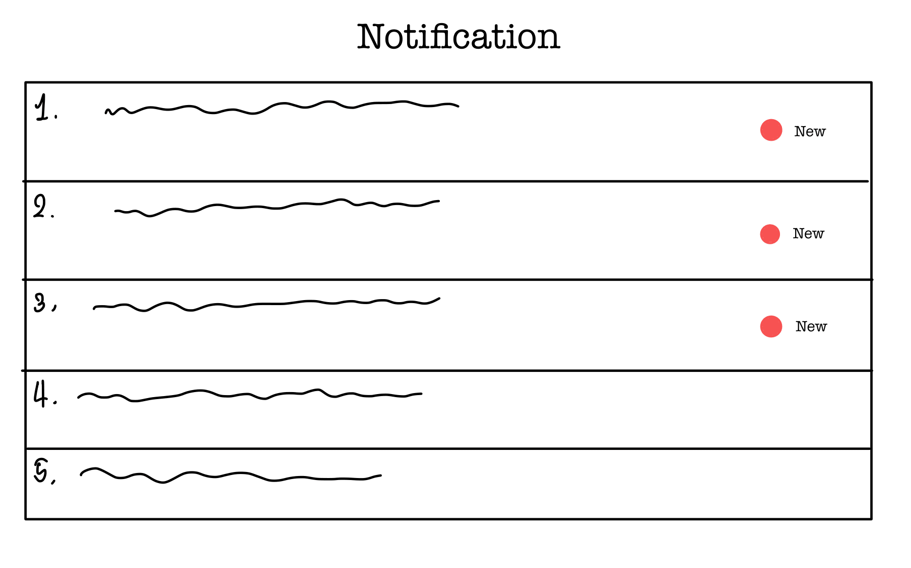**

**Support Live Chat  
  
